Site purpose
The site's purpose is to make The Temple Inn & Suites known among the members of the Church, workers, and leaders that go to the temple. Show all the benefits, services, and commodities this Company offers to its clients.

Target Audience
The target audience is families.
We focus our site content on families, as well as we provide services for whole families who come to enjoy and feel serenity, we point to that with this website.

Site map
Home
Temples
Reservations
Services
Reception
Full-time temple missionary

Color Scheme

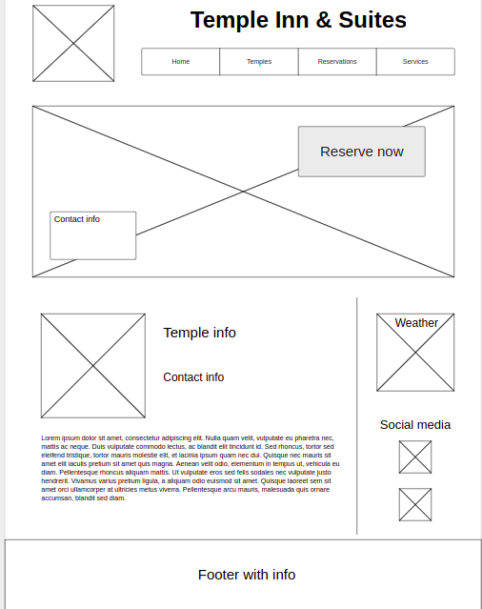
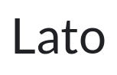
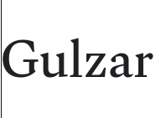
Typography

- Titles

- Content

Wireframe

